Low Level Design

# Analyze International Debt Statistics

|  |  |
| --- | --- |
| **Written By** | Kushal Chaple |
| **Document Version** | 0.3 |
| **Last Revised Date** |  |

**DOCUMENT CONTROL**

## Change Record:

|  |  |  |  |
| --- | --- | --- | --- |
| **VERSION** | **DATE** | **AUTHOR** | **COMMENTS** |
| 0.1 | 19- Aug -  2023 | Author 1 | Introduction and architecture defined |
| 0.2 | 20 - Aug -  2023 | Author 1 | Architecture & Architecture description appended and  updated. |
|  |  |  |  |
|  |  |  |  |

**Approval Status:**

|  |  |  |  |  |  |
| --- | --- | --- | --- | --- | --- |
| **VERSION** | **REVIEW**  **DATE** | **REVIEWED BY** |  | **APPROVED BY** | **COMMENTS** |
|  |  |  |  |  |  |

# Contents

#### Introduction 04

* 1. **What is Low-Level Design Document? 04**

|  |  |  |
| --- | --- | --- |
| **1.2** | | **Scope 04** |
| **2.** | **Architecture 05** | |
| **3.** | **Architecture Description 08** | |
|  | **3.1** | **Data Description 08** |
|  | **3.2** | **Web Scrapping 08** |
|  | **3.3** | **Data Transformation 08** |
|  | **3.4** | **Data insertion into database 08** |
|  | **3.5** | **Connection with SQL server 08** |
|  | **3.5** | **Export Data from database 12** |
|  | **3.6** | **Deployment 12** |
| **4.** | **Unit** | **test cases 15** |

# Introduction

## What is Low-Level design document?

The goal of the LDD or Low-level design document (LLDD) is to give the internal logic design of the actual program code for the House Price Prediction dashboard. LDD describes the class diagrams with the methods and relations between classes and programs specs. It describes the modules so that the programmer can directly code the program from the document.

## Scope

Low-level design (LLD) is a component-level design process that follows a step-by-step refinement process. The process can be used for designing data structures, required software architecture, source code and ultimately, performance algorithms. Overall, the data organization may be defined during requirement analysis and then refined during data design work.

# Architecture

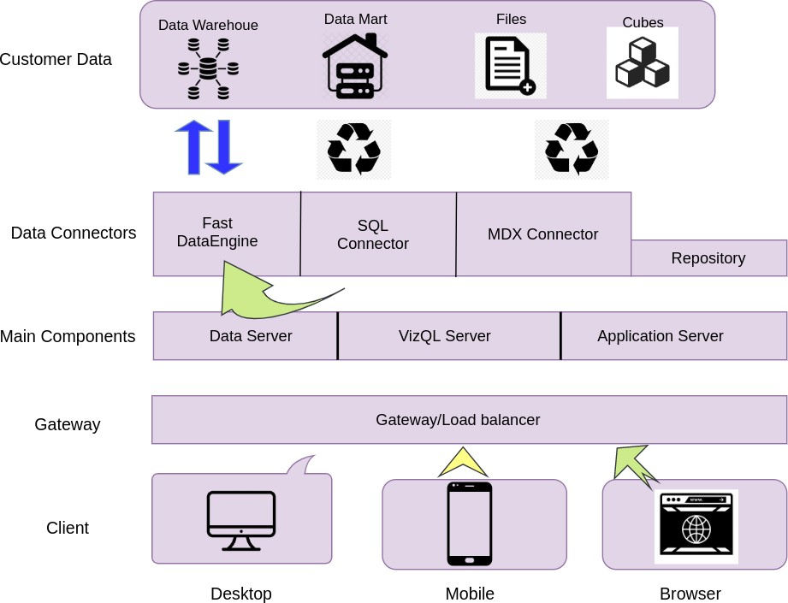

**Power Bi Server Architecture**

Power Bi has a highly scalable, n-tier client-server architecture that serves mobile clients, web clients and desktop-installed software. Power Bi Server architecture supports fast and flexible deployments.

The following diagram shows PowerBI Server’s architecture:

**LOW LEVEL DESIGN**

**6**

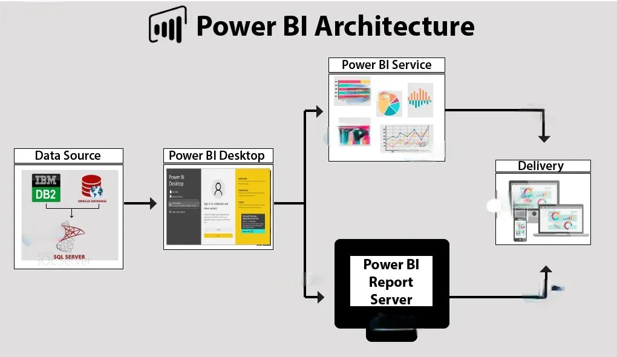

Let us learn about the components of Power BI architecture in detail.

**1.Data Sources :** An essential component of Power BI is its vast range of data sources. You can import data from files in your system, cloud-based online data sources or connect directly to live connections. If you import from data on-premise or online services, there is a limit of 1 GB.

**2.Power BI Desktop:** Power BI Desktop is a client-side tool known as a companion development and authoring tool. This desktop-based software is loaded with tools and functionalities to connect to data sources, transform data, model, and create reports. You can download and install Power BI Desktop in your system for free. Using Power BI Desktop features, one can do data cleansing, create business metrics and data models, define the relationship between data, define hierarchies, create visuals and publish reports.

**3.Power BI Service:**Power BI Service is a web-based platform where you can share reports made on Power BI Desktop, collaborate with other users, and create dashboards.

4.**Power BI Report Server:** The Power BI Report Server is similar to the Power BI Service. The only difference between these two is that Power BI Report Server is an on-premise platform. Therefore, it is used by organizations who do not want to publish their reports on the cloud and are concerned about their data security. Power BI Report Server enables you to create dashboards and share your reports with other users following proper security protocols. To use this service, you need to have a Power BI Premium license.

5. **Power BI Gateway:** This component is used to connect and access on-premise data in secured networks. Power BI Gateways are generally used in organizations where data is kept in security and watch. Gateways help to extract out such data through secure channels to Power BI platforms for analysis and reporting.

6. **Power BI Mobile:** Power BI Mobile is a native Power BI application on iOS, Android, and Windows mobile devices. For viewing reports and dashboards, these applications are used.

7. **Power BI Embedded:**Power BI Embedded offers APIs which are used to embed visuals into custom applications.

# Architecture Description

## Data Description

The Dataset contains World Bank Debt Statistics of all countries that takes Debt from World Bank considering the year of debt and Indicator code and name.

* + 1. Country Name: List of countries world-wide.
    2. Country Code: Short form or code for each country name.
    3. Indicator Name: List of type of indicator w.r.t debt taken.
    4. Indicator Code: Short-form or code for Indicator name.
    5. Year: list of year w.r.t debt taken
    6. Debt($): Amount of debt taken in $.

## Web Scrapping

Web scraping is a technique to automatically extract content and data from websites using bots. It is also known as web data extraction or web harvesting. Web scrapping is made simple now days, many tools are used for web scrapping. Some of python libraries used for web scrapping are Beautiful Soup, Scrapy, Selenium, etc.

## Data Transformation

In the Transformation Process, we will convert our original datasets with other necessary attributes format. And will merge it with the Scrapped dataset.

## Data Insertion into Database

1. Database Creation and connection - Create a database with name passed. If the database is already created, open the connection to the database.
2. Table creation in the database.
3. Insertion of files in the table

## Make the SQL connection and set up the data source

**Step 1: Configuring Power Bi**

Launch Power Bi on your workstation and select SQL Server from the connect column on the left. This will open a dialogue box where you need to provide the connection details for SQL Server.

To connect with Power Bi, you will need to provide information about the server which hosts your database. If you want to connect to a contained database, you can also specify the name of thedatabase

## Export Data from Database

Data Export from Database - The data in a stored database is exported as a CSV file to be used for Data Pre-processing.

## Deployment.

Once you’ve completed your dashboard, follow these steps:**- Server, Power Bi Public, Save to Power Bi Public As**

You may be prompted to log into your Power Bi Public profile first if this is your first time publishing.

## 3.7 Dashboard Visual:

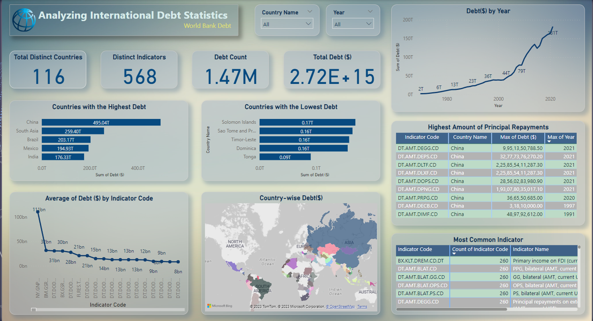



1. **LOW LEVEL DESIGN**

# Unit Test Cases

|  |  |
| --- | --- |
| **TEST CASE DESCRIPTION** | **EXPECTED RESULTS** |
| Country name slicer | When clicked on the slicer, a dropdown should occur which has  all the countries listed. |
| Year Slicer | When clicked on the slicer, a dropdown should occur which  has Year from 1970 to 2021. |
| Total Debt | Total Calculated Debt amount in $. |
| Total Countries | Countries count which has debt. |
| Countries with Highest and Lowest debt | Top 5 countries with highest and lowest debt by the total debt taken in $. |
| Relation between Debt amount and Year | Here a time series graph is shown of Debt amount VS Year. |
| Highest Principal Debt Repayment | Countries with the highest amount of Debt Principal Repayment Indicator. |